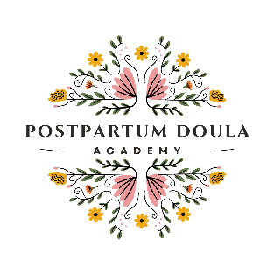

**APPLICATION FOR POSTPARTUM DOULA CERTIFICATION**

LAST NAME Click or tap here to enter text. FIRST NAME Click or tap here to enter text.

ADDRESS Click or tap here to enter text. CITY, STATE, ZIP Click or tap here to enter text.

EMAIL Click or tap here to enter text. PHONE Click or tap here to enter text.

WEBSITE Click or tap here to enter text.

I have taken the Postpartum Doula Academy’s full Postpartum Doula course and received my completion certificate. OR

I am a current student of an approved course (approved by NCSA) and the Postpartum Doula course for students and received an attached my completion certificates.

I have supported five families for a minimum of 40 hours each, within a two-year period,

I have attached my r**esume** which shows the 5 supported families

I have attached my **evaluations** or feedback from the families I have supported.

I have attached the list of books I have read for the **3 reading requirements.**

I have attached my **background check** which is under one year old. (Trustline Preferred)

I have attached **Three postpartum clients using holistic measures**. This could include the use of herbal remedies, essential oils, homeopathy remedies, lotions, or concoctions. I have submitted details of what I did and how it helped.

I I have completed the **PDA workbook** and it is attached to this form

I took a postpartum doula class with another organization which was Click or tap here to enter text.

Date I completed that courseClick or tap to enter a date.

I am applying for:

American Academy of Drugless Practitioners Certificate OR  Postpartum Doula Academy Certificate

I have paid my application fee of $250 for Postpartum Doula Academy total cost is $250

or

I have paid my application fee of $150 for Postpartum Doula Academy Certification American Academy of Drugless Practitioners, understanding there will be an additional fee from them for certification. Total cost is apx 395

The entire process should take apx 30 days if you have submitted all the required forms and done the required steps.

There are NO REFUNDS, so please be sure you have submitted everything correctly.

I hereby certify that the above information provided in this application is true and accurate to the best of my knowledge.

____________________________ __________________

Signature Date